Pedagogical Toolbox
Healthy Data

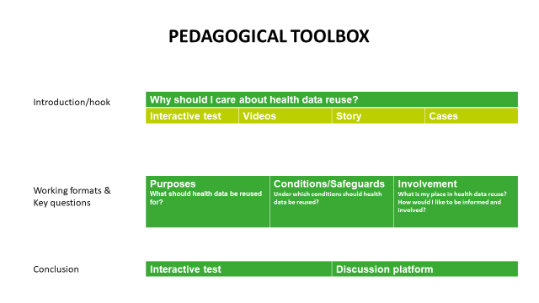

Introduction: Hooks
The goal of the Healthy Data e-consultation is to deliberate together with citizens about how health data should be governed in the European Union. We are looking to co-create an ethical and societal framework for the use of health data beyond individual care. The only way we can build a health data space that will respect the values and principles of citizens, is when enough citizens are willing to have their say. The platform is built around three steps: inform, deliberate, produce. Therefore, we provide neutral and engaging information, we provide questions, cases and other discussion materials to stimulate deliberation and we give citizens the opportunity to share their opinion and produce their own recommendations. These contributions will be analyzed in depth and form the basis of the ethical framework for the European Health Data Space. We believe that classrooms offer an ideal circumstance to inform young citizens, deliberate with them on important societal issues and in this project we give them the opportunity to make their voices heard.

We thank you for your interest in the Healthy Data project and for your contribution. We welcome all input and improvements to this pedagogical toolbox, which will first be distributed in Belgium, France and the UK, but might be used in even more contexts as the European Health Data Space develops further. Feedback can be sent to wannes.vanhoof@sciensano.be.

Why is it important to talk about health data reuse?
We suggest introducing the students to the issue of health data reuse by talking about these two points:

- It is already happening
Every interaction you have with the healthcare system (every consultation with a healthcare professional, every purchase at the pharmacy, every reimbursement, every wearable …) leaves behind data. After these data served their primary use for you, they often remain available for reuse for other purposes. Learn more about what health data is used for here.

- It has an impact on you and on our society
Data about you is information about you and information is power. Who can have access to this information? What can they do with it? What kind of information about you would you like to see protected? Learn about what health data is and how it can impact you here.

Different options to get students hooked
- Interactive test
This is a short interactive quiz that can take students through three scenario’s where health data is being reused and they can decide what they would like to do. At the end, it generates a profile of what kind of data user they are.

- Videos
There are two short video’s (around 2 minutes) that provide a story or examples to illustrate the importance of health data reuse.
There are several TED talks that might serve a purpose during a class, for example explaining alternative ways to sharing health data (Let’s pool our medical data or Own your body’s data)

- Story
Robert has cancer and we follow his story as the second life of his data unfolds. This story will be live on the homepage of the consultation with animations and links before January 28th 2022.

- Cases
Here you can find many different cases that illustrate how health data is reused in practice. Stay tuned for updates.

Working formats & key questions for discussion
The Healthy Data platform is built around three main topics. These topics dominate the information materials, the interactive test, Robert’s story and the discussion platform. Classes can focus on one or more questions as a starting point, but the discussions will surely evolve into different topics as they are all interlinked. For teachers who would like to build a powerpoint presentation for their students, we included some visual elements that are free to use in Annex 2.

Purposes: What should health data be reused for?
What type of health data should be reused? By whom? For which purpose(s)? What benefits do you expect from it?

Many of the informational materials on the platform give examples of how health data is being reused in practice. The natural segue for ethics is to question current practices in light of what should happen in your opinion.
Potential analogies: data from social media, private communication, COVID-19 measures

Suggested working formats:
- Link to the story: To what extent do you recognize the story of Robert? In what kind of way have you ever thought about or been confronted with a health data journey as presented in this story?
- What health data about me exists in the world? What is happening with this data?
- Pro/con lists for different instances of health data reuse (+ justification, focus on the ‘why’)
- Link to cases: Which case inspires you most? Why?
- Link to conditions and safeguards: does the way in which data is used influence the support for certain uses?
- Link to involvement: should I decide which uses of my data are justified or which rules are in place to govern my data? How would I like to be involved?

Conditions and safeguards: Under which conditions should health data be reused?
Which mechanisms and protections should be put in place to ensure an appropriate and secure reuse of our health data? Why?

The important consideration when thinking about conditions and safeguards for health data reuse is that there are always tradeoffs. For example, many restrictive rules might do a good job of protecting privacy rights, but they will make it harder to reuse health data for legitimate goals like improving health and advancing scientific knowledge.

Suggested working formats:
- Who can access my data? How can health data be reused safely?
- When you think of conditions and safeguards, what are you thinking of specifically? IT tools? Laws and regulations? Experts and committees? Other things? What might be advantages and disadvantages of these? How might they be complementary or conflicting?
- In which aspect of the health data reuse process are safeguards most important? Should they control who is accessing and reusing the data? Should they rather focus on the purposes and specific ways of reuse? What could be vulnerable spots in the process of health data reuse that demand specific protection?
- Where should we land on the balancing act between protecting privacy and promoting scientific progress?
- Students could build their own system and think of their own set of rules that would lead them to trust health data reuse under these conditions.
- Link to involvement: Should I be the one in control of health data reuse? Should my doctor be? An independent council of experts? …

Involvement: What is my place in health data reuse? How would I like to be informed and involved?
What type of information on health data reuse would you like to have? How would you like to receive it? What should be the role of citizens in reuse of their health data beyond individual care? What are suitable contexts and ways to be able to perform this role?

This is the most important question that we want to answer for the European Commission. It is intimately linked to both other questions, but the focus here is on structural organization of citizen engagement on this issue.

Suggested working formats:
- Should citizens simply trust experts? Should they be sensitized, nudged, convinced or obliged to participate in health data reuse? Should they get a more active role? If so, what should this look like?
- In Robert’s story, he is considering different options regarding involvement in health data reuse. Which one(s) would you choose? Why? Are there other options you would prefer?

Conclusion

Have your say
The best way to share opinions on the platform is to create an account and type a short description of one or more ideas someone wants to share about the reuse of health data. We included a step by step guide to creating an account and sharing an opinion (Annex 3). In this guide, we explain how student names can be pseudonimised and which possibilities exist to retrieve the input given by students should teachers be interested in using the contribution on the platform for a test or homework.

Interactive test
Within the interactive test, there is an option to share an opinion on every topic. These opinions will be included on the platform anonymously if they comply with the platform’s charter of use.

