Quality of Laboratories
Belgian National Reference Centers
for Rare Diseases

Call for application 2023

-

Simplified Application Form

_

Sciensano

BIOLOGICAL HEALTH RISKS – Quality of Laboratories

Action 1 – Belgian Plan for Rare Diseases

February 2023 • Brussels • Belgium
Internal reference number: Sciensano-NV-2023-14
Approved by: Dr. Arnaud Capron, Head of service
_

Dr. Nathalie Vandevelde (PharmD, PhD)
•

Contact person: Nathalie Vandevelde • T+32 2 642 55 89 • nathalie.vandevelde@sciensano.be

With the financial support of the National Institute for Health and Disability Insurance
Table of contents
_

TABLE OF CONTENTS 3
Abbreviations 5
Introduction 7
A. Context and objectives of the call for applications 7
B. Profile of the Belgian National Reference Centers for rare diseases 8
C. Missions of the Belgian National Reference Centers for rare diseases 8
D. General instructions 9
E. Scope of the call for applications 10
application documents 11
Simplified application form – questionNaire 13
1. Structure, direction and organization 13
2. Quality management 15
3. Medical and scientific expertise 17
4. Sustainability of the activities 21
SIMPLIFIED APPLICATION FORM – Agreement form 23
Tables 25

Abbreviations
_
- EQA : External quality assessment
- ISO : International organization for standardization
- LHUB-ULB : Laboratoire Hospitalier Universitaire de Bruxelles – Université libre de Bruxelles
- NRC : National Reference Center
- QM : Quality manual
- SDS-PAGE : Sodium dodecyl sulfate polyacrylamide gel electrophoresis
- SLA : Service-level agreement
- TAT : Turnaround time
- UZ : Universitair ziekenhuis

Introduction
_
A. Context and objectives of the call for applications
This call for applications is organized in 2023 by Sciensano as part of a five-year procedure for the selection of reference laboratories, called "National Reference Centers (NRC)", for the diagnosis and/or follow-up of rare diseases, using medical analyses of clinical biology.

The previous call for applications took place in 2017-2018 and enabled to select, recognize and fund 18 NRC for rare diseases (cf. Table 1) for a period of five years (2019-2023).

The recognition and funding of the NRC for rare diseases enables to reduce the patients’ and laboratories’ costs related to the performance of the targeted analyses. In addition, the attribution of the NRC recognition allows Sciensano to closely monitor the annual volumes and the quality (participation in quality controls, accreditation, development of expertise networks, and (inter)national scientific projects) of the analyses carried out by the NRC.

The present selection procedure allows the Belgian laboratories of clinical biology to:
- renew their recognition of expertise as NRC for a new period of five years, namely from January 1, 2024 to December 31, 2028 (simplified application form);

- apply for other analyses among those included in the scope of the call for applications validated by the Belgian Commission for Clinical Biology and the INAMI-RIZIV in 2022 (full application form).

This selection procedure will take place between March and July 2023.
Timeline of the call for applications 2023:
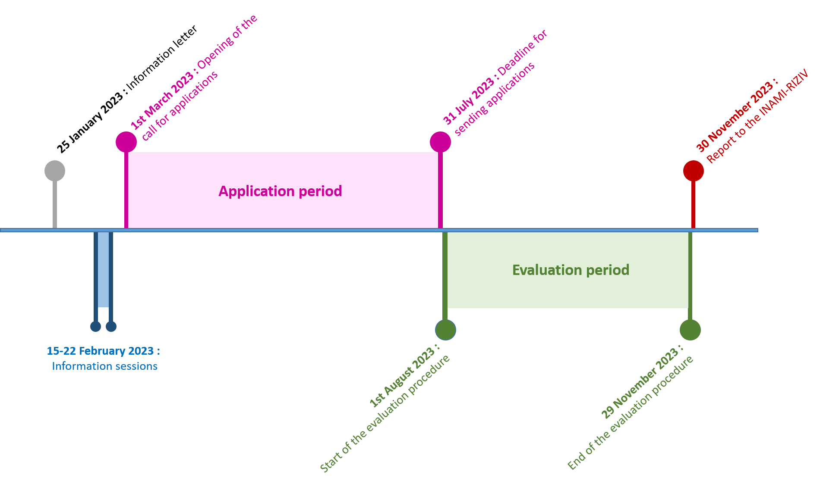
B. Profile of the Belgian National Reference Centers for rare diseases:
- Any Belgian public or private medical laboratory of clinical biology that fulfills the quality requirements defined by the Royal Decree of 3 December 1999 about the licensing of the laboratories of clinical biology may apply, individually or in association (consortium) with one or several other medical laboratory(ies) or academic scientific research laboratory(ies);

- Having the required knowledge and expertise in the fields of (i) the diagnosis/follow-up of specific rare diseases, (ii) the validation of diagnostic tests, (iii) the development of new technologies, (iv) scientific research activities, and being able to provide proof of this expertise by means of scientific publications, reports, or through scientific collaborative projects;

- Offering services to licensed medical laboratories, in particular recommendations for the collection and treatment of the samples (cf. C.2. below), the interpretation of analytical results and by providing them with information on the response time (= turnaround time) required for a test;

- Using a quality management system, including the participation in external quality controls, as well as a complaints system and a laboratory informatics management system (LIMS);

- Committing to be accredited according to the ISO15189 norm for the performance of the analyses carried out by the NRC within two years from their official recognition of expertise for the period 2024-2028 (= the date of signature of the agreement between Sciensano and the NRC);

- Belonging to international networks of expertise focused on rare diseases for which the reference center has recognized expertise;

- Disposing of the necessary infrastructure, equipment and qualified staff required for the performance of the analysis during at least five years.

C. Missions of the Belgian National Reference Centers for rare diseases:
- Contributing to the diagnosis, confirmation and follow-up of rare diseases by carrying out specific analyses of clinical biology, and participating in the validation of new analyses;

- Providing technical support and information to the medical laboratories of clinical biology regarding:
  - The conditions for the collection of the samples
  - The conditions for the treatment, sampling and storage of the samples
  - The conditions for the transport of the samples
  - The analysis request form, including the list of the necessary clinical information
  - The interpretation of analytical results
  - The turnaround time for the analytical results

- Contributing to scientific, clinical and/or epidemiological research in the field of rare diseases and related analyses of clinical biology;

- Sending the annual supporting documents to Sciensano for the writing of the scientific and financial reports of the NRC, namely the (i) annual volumes of analyses, (ii) cost of the analysis, (iii) proof of participation in a quality control and accreditation of the NRC for the analysis for which the NRC has been recognized, (iv) any invoices for the outsourcing of other analyses of clinical biology, prescribed in the context of rare diseases and unavailable in Belgium, to foreign expert laboratories;

- providing advice to the Belgian public health authorities in order to improve the diagnosis and follow-up of rare diseases.

D. General instructions :
- We draw your attention to the fact that two different application forms are available during the selection procedure 2023 for the Belgian NRC for rare diseases :

- The simplified application form that can be used by existing NRC that want to apply for a renewal of their recognition of expertise for a particular analysis, during a new five-years period, namely from January 1, 2024 to December 31, 2028.

- The full application form that can be used by any Belgian laboratory of clinical biology in order to apply for an analysis included in the scope of the call for applications when the laboratory is not yet recognized as NRC for the performance of the analysis considered.

- This document is the simplified version of the application form.
- The closing date for the submission of the applications is 31 July 2023.
- The application form that should be completed consists of several parts :
- the questionnaire;

- the agreement document for the submission of the application that must be signed by the director(s) of your laboratory(ies) and by the clinical biologist(s) responsible for the performance and validation of the analysis considered.
- The application form is a Microsoft Office Word document. It can be opened by any Word version not older than version 2003.
- Please indicate the number of the analysis for which you are applying at the top of each page of the application form. You can find the number of each analysis included in the scope of the call for application on the next page (Scope of the call for applications).
- If you want to apply for several analyses included in the scope of the call for application, please submit one application form per analysis (using the simplified or full version of the application form, depending on your current recognition [or absence of current recognition] for the analysis considered).
- You can save the application form as « docx » file and then open and update it as many times as needed.
- Please send the filled application form by email to the following address : nathalie.vandevelde@sciensano.be
If desired, you can also send your application by mail to the following address. You will receive a confirmation of the good reception of your application by email.
Dr. Nathalie Vandevelde
Sciensano
Service of Quality of Laboratories
Rue Juliette Wytsmanstraat 14
B-1050 Bruxelles/Brussel

E. Scope of the call for applications :

Number | Analyses of clinical biology
Clinical chemistry :
1 | Assessment of intra-leukocyte cystine
2 | Assessment of 5-methyltetrahydrofolate in cerebrospinal fluid
3 | Assessment of α-aminoadipic semialdehyde in urine and/or plasma
4 | Assessment of δ1-piperideine-6-carboxylate in urine and/or plasma
5 | Assessment of the B6 vitamers in plasma
6 | Measurement of the activity of the dihydropteridine reductase in Dried Blood Spots
7 | Assessment of the pterins in urine and/or cerebrospinal fluid
8 | Assessment of erythrocyte plasmalogens
9 | Assessment of plasma porphobilinogen
10 | Spectrofluorimetric assessment of plasma porphyrins
11 | Fractionation of plasma porphyrins (confirmation test)
12 | Assessment of free erythrocyte protoporphyrins
13 | Assessment of protein 14.3.3 and Real-time quaking-induced conversion (RT-QuIC) assay in cerebrospinal fluid
Hematology :
14 | Analysis of the deformability of erythrocytes using ektacytometry and separation of red blood cells membrane proteins by SDS-PAGE
15 | Cytogenetic radiosensitivity assay
Immunology :
16 | Immunological assessment of complement component Factor B
17 | Immunological assessment of complement component Factor Bb
18 | Immunological assessment of complement component Factor D
19 | Immunological assessment of complement component Factor P
Quality of Laboratories
Belgian National Reference Centers
for Rare Diseases

Call for application 2023

-

Application Documents

Simplified version for existing NRC

_

Simplified Application FORM - Questionnaire

_

Structure, direction and organization

Number of the medical analysis considered (cf. page 10) :
1. Name and full address of the Belgian laboratory(ies) of clinical biology :
2. Licensing number of the Belgian laboratory(ies) of clinical biology :
3. Name, telephone number and email address of the Director of the Belgian laboratory(ies) of clinical biology :
4. Name, telephone number and email address(es) of the clinical biologist(s) responsible for the performance of the analysis and his/her substitute(s) :
5. In the case of a consortium between a laboratory of clinical biology and an academic scientific research laboratory, please specify the name(s), affiliation(s), telephone number(s) and email address(es) of the principal investigator(s) involved in the performance of the analysis :
6. Name, telephone number and email address(es) of the quality coordinator(s) of the laboratory(ies) of clinical biology :

Simplified Application FORM - Questionnaire

_

1. Structure, direction and organization

Number of the medical analysis considered (cf. page 10) :
7. If you submit an application in the name of a consortium :
- provide a copy of the service-level agreement (SLA) form established between the laboratories (in PDF format and named in the following manner: licensing number of the laboratory(ies)-ANNEX-1-SLA.pdf)

- please briefly justify the purpose and relevance of the consortium in the frame below (max 1500 characters).

Simplified Application FORM - Questionnaire

_

2. Quality management

Number of the medical analysis considered (cf. page 10) :
8. Please provide a PDF copy (named as specified below) and/or the link of/to the following documents :

- Quality manual of the laboratorie(s): licensing number of the laboratory(ies)-ANNEX-2-QM.pdf
- Validation file for the analysis considered: licensing number of the laboratory(ies)-ANNEX-3-validation.pdf
- ISO 15189 accreditation certificate if your laboratory(ies) is/are already accredited for the performance of the analysis considered: licensing number of the laboratory(ies)-ANNEX-4-accreditation.pdf
- Analysis request form : licensing number of the laboratory(ies)-ANNEX-5-request form.pdf
- In the frame below, please provide the internet links to the (i) whole content of your quality manual(s), and (ii) website(s) of your laboratory(ies) where practical information about the analysis considered can be found.
9. Please mention the name of the provider(s) of External Quality Assessment Scheme(s)/ring test(s) to which your laboratory(ies) participate(s) in 2023 for the analysis considered.
10. Please indicate your average turnaround time (TAT)* (expressed in days) for the analysis considered.
*: The turnaround time is the time interval between the sending of the analysis request to your laboratory, and the moment at which the prescriber receives the validated analytical results.

Simplified Application FORM - Questionnaire

_

2. Quality management

Number of the medical analysis considered (cf. page 10) :
11. If the pre-analytical conditions requested by your laboratory for the analysis considered and/or the unit(s) used by your laboratory(ies) for the reporting of the analytical results have changed since 01.01.2022, please briefly describe these modifications in the frames below.
Min. volume/amount of sample and matrix :
Sampling conditions :
Storage conditions :
Transport conditions :
Unit(s) :

Simplified Application FORM - Questionnaire

_

3. Medical and scientific expertise

Number of the medical analysis considered (cf. page 10) :
12. If you want to mention guidelines or clinical algorithms (focused on the analysis considered and/or the rare diseases for which this analysis is used) that have been developed by your laboratory(ies), please feel free to attach a PDF copy (named as specified below) and/or the link to the document in the frame below.

- licensing number of the laboratory(ies)-ANNEX-6-name of the document.pdf
13. If you want to describe your recent scientific/clinical projects or peer-reviewed scientific publications related to the analysis or rare diseases considered, please add this description in the frames below and on the next page (max. 5000 characters).

Simplified Application FORM - Questionnaire

_

3. Medical and scientific expertise

Number of the medical analysis considered (cf. page 10) :

Simplified Application FORM - Questionnaire

_

3. Medical and scientific expertise

Number of the medical analysis considered (cf. page 10) :
14. If you want to describe your ongoing international collaborations or participation to international reference networks focused on the analysis considered and/or rare diseases for which this analysis is used, please add this description in the frames below and on the next page (max. 5000 characters).

Simplified Application FORM - Questionnaire

_

3. Medical and scientific expertise

Number of the medical analysis considered (cf. page 10) :

Simplified Application FORM - Questionnaire

_

4. Sustainability of the activities

Number of the medical analysis considered (cf. page 10) :
15. Does your laboratory want to perform the analysis considered during at least 5 years and do you dispose of the required infrastructure and qualified staff to complete this task during this time period ?
☐ | Yes | ☐ | No

SIMPLIFIED APPLICATION FORM -

Agreement form
_
Number of the medical analysis considered (cf. page …):
A. Name(s) of the laboratory(ies) of clinical biology:
B. Names of academic scientific research laboratory(ies)
C. Licensing number(s) of the laboratory(ies) of clinical biology mentioned in A:
D. Name(s) and first name(s) of the director(s) of the laboratory(ies) mentioned in A and B:
E. Name(s) and first name(s) of the clinical biologist(s) in charge of the analysis:
F. Please tick the adequate boxes below:
☐ | We have read and understood the context, objectives and modalities of the call for application, as well as the profile, missions and selection criteria for the National Reference Centers for rare diseases.
☐ | We certify that the answers provided in the application form are correct and reflect the activities of the laboratory.
☐ | We give full permission for the submission of the present application to Sciensano.
Place : |  |  |  | Date :
Signatures of the Director(s) of the laboratory(ies) and clinical biologist(s) mentioned in D and E:

TABLEs
_
Table 1. List of the NRC for rare diseases recognized for the period 2019-2023 and related institutions

Analyses of clinical biology performed by the NRC | Related institution(s)
Clinical chemistry :
Assessment of intra-leukocyte cystine | Cliniques universitaires St Luc
Assessment of 5-methyltetrahydrofolate in cerebrospinal fluid | Cliniques universitaires St Luc
Assessment of α-aminoadipic semialdehyde in urine and δ1-piperideine-6-carboxylate in plasma | Consortium UZ Antwerpen - Cliniques universitaires St Luc
Assessment of the B6 vitamers in plasma | Centre hospitalier universitaire de Liège
Measurement of the activity of the dihydropteridine reductase in Dried Blood Spots and assessment of pterins in urine | Consortium Centre hospitalier universitaire de Liège - UZ Gent
Assessment of erythrocyte plasmalogens | UZ Gent
Assessment of plasma porphobilinogen | LHUB-ULB
Spectrofluorimetric assessment of plasma porphyrins | LHUB-ULB and UZ Leuven (2 NRC)
Fractionation of plasma porphyrins (confirmation test) | LHUB-ULB
Assessment of free erythrocyte protoporphyrins | LHUB-ULB and UZ Leuven (2 NRC)
Hematology :
Red blood cells membrane disorders : Analysis of the deformability of erythrocytes using ektacytometry and separation of red blood cells membrane proteins by SDS-PAGE | LHUB-ULB
Cytogenetic radiosensitivity assay | Consortium UZ Gent-UGent
Immunology :
Immunological assessment of complement component Factor B | LHUB-ULB
Immunological assessment of complement component Factor Bb | LHUB-ULB
Immunological assessment of complement component Factor D | LHUB-ULB
Immunological assessment of complement component Factor P | LHUB-ULB

